**Discrete probability distributions**

Recently, you learned that data professionals use probability distributions to model different kinds of datasets, and to identify significant patterns in their data. Recall that a **probability distribution** describes the likelihood of the possible outcomes of a random event. Discrete probability distributions represent discrete random variables, or discrete events. Often, the outcomes of discrete events are expressed as whole numbers that can be counted. For example, rolling a die can result in a 2 or a 3, but not a decimal value such as 2.575 or 3.184.

In this reading, you’ll get an overview of the main attributes of four common discrete probability distributions:

* Uniform
* Binomial
* Bernoulli
* Poisson

**Discrete probability distributions**

**Uniform distribution**

The uniform distribution describes events whose outcomes are all equally likely, or have equal probability.

For example, rolling a die can result in six outcomes: 1, 2, 3, 4, 5, or 6. The probability of each outcome is the same: 1 out of 6, or about 16.7%.

You can visualize a distribution with a graph, such as a histogram. For a discrete distribution, the random variable is plotted along the x-axis, and the corresponding probability is plotted along the y-axis. In this case, the x-axis represents each possible outcome of a single die roll, and the y-axis represents the probability of each outcome.

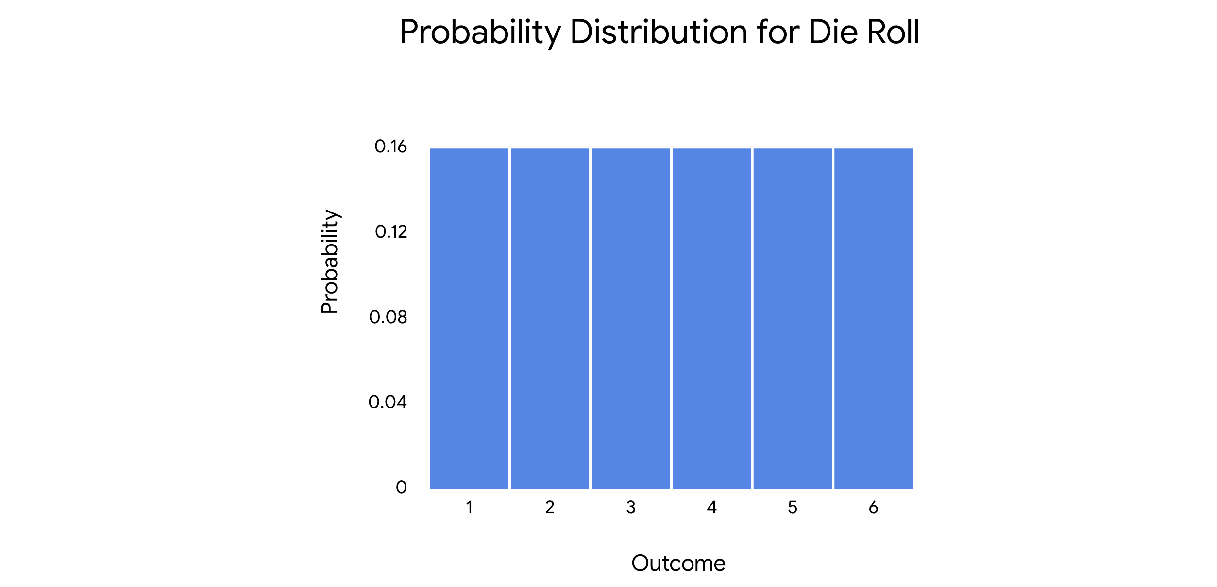

***Note:*** *Data professionals often use the uniform distribution as part of more complex statistical methods, like Monte Carlo simulations. A detailed discussion of these methods is beyond the scope of this course.*

***Note:*** *The uniform distribution applies to both discrete and continuous random variables.*

**Binomial distribution**

The **binomial distribution** models the probability of events with only two possible outcomes: success or failure. These outcomes are mutually exclusive and cannot occur at the same time.

This definition assumes the following:

* Each event is independent, or does not affect the probability of the others.
* Each event has the same probability of success.

Remember that success and failure are labels used for convenience. For example, if you toss a coin, there are only two possible outcomes: heads or tails. You could choose to label either heads or tails as a successful outcome based on the needs of your analysis.

The binomial distribution represents a type of random event called a binomial experiment. A binomial experiment has the following attributes:

* The experiment consists of a number of repeated trials.
* Each trial has only two possible outcomes.
* The probability of success is the same for each trial.
* And, each trial is independent.

An example of a binomial experiment is tossing a coin 10 times in a row. This is a binomial experiment because it has the following features:

* The experiment consists of 10 repeated trials, or coin tosses.
* Each trial has only two possible outcomes: heads or tails.
* Each trial has the same probability of success. If you define success as heads, then the probability of success for each toss is the same: 50%.
* Each trial is independent. The outcome of one coin toss does not affect the outcome of any other coin toss.

On the histogram, the x-axis shows the number of heads, and the y-axis shows the probability of getting each result.

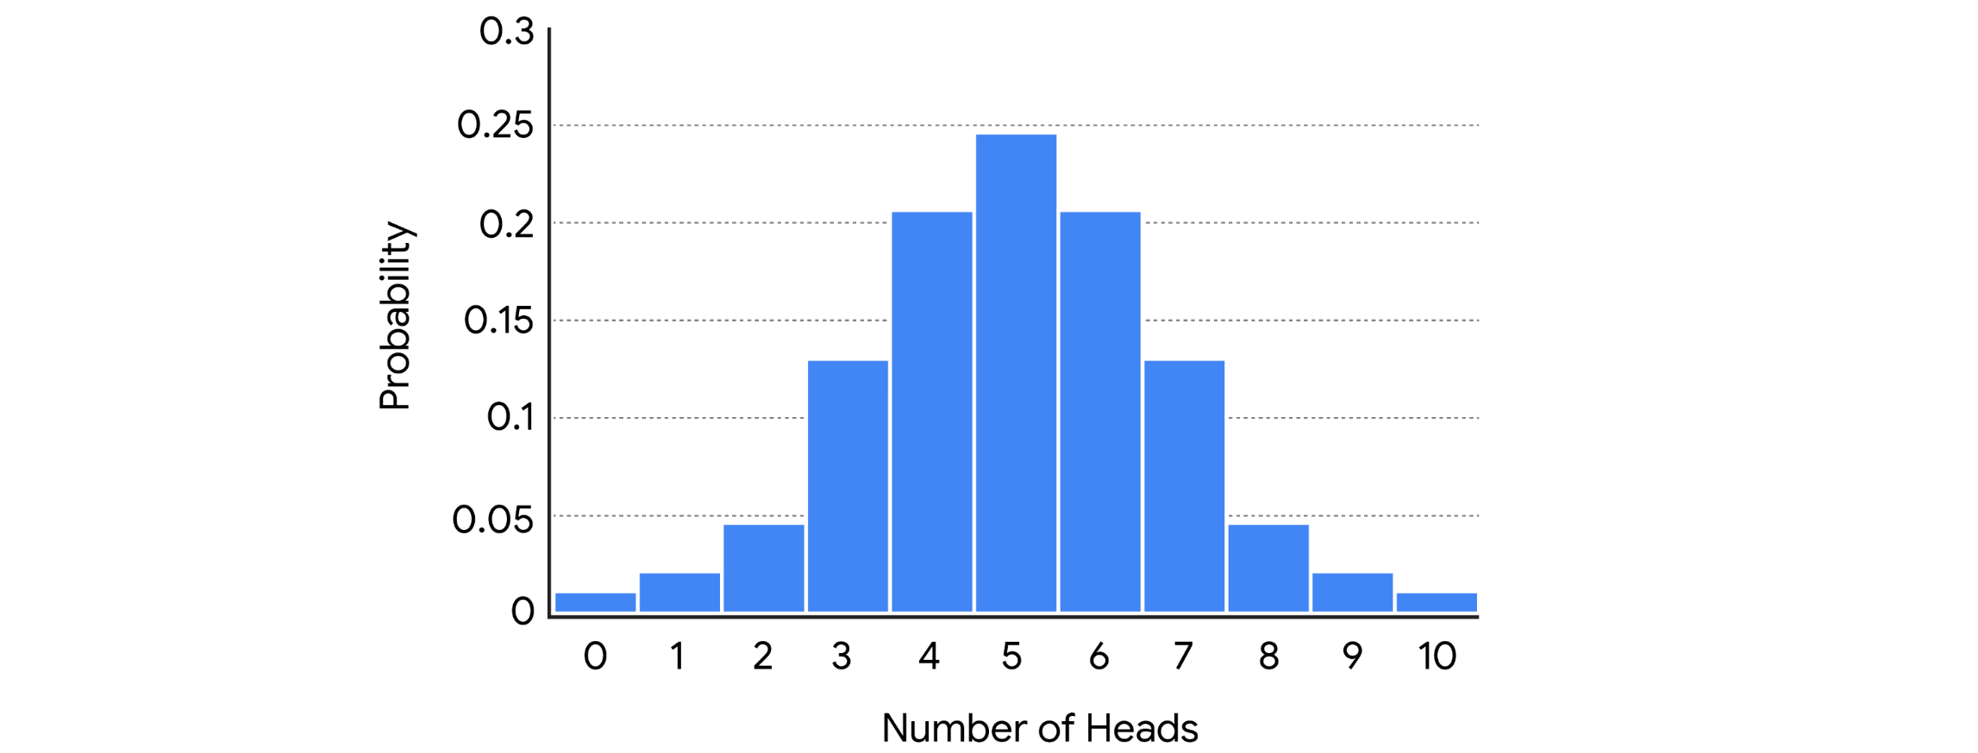

Data professionals might use the binomial distribution to model the probability that:

* A new medication generates side effects
* A credit card transaction is fraudulent
* A stock price rises in value

In machine learning, the binomial distribution is often used to classify data. For example, a data professional may train an algorithm to recognize whether a digital image is or is not a specific type of animal, like a cat or a dog.

**Bernoulli distribution**

The Bernoulli distribution is similar to the binomial distribution as it also models events that have only two possible outcomes (success or failure). The only difference is that the Bernoulli distribution refers to only a single trial of an experiment, while the binomial refers to repeated trials. A classic example of a Bernoulli trial is a single coin toss.

On the histogram, the x-axis represents the possible outcomes of a coin toss, and the y-axis represents the probability of each outcome.

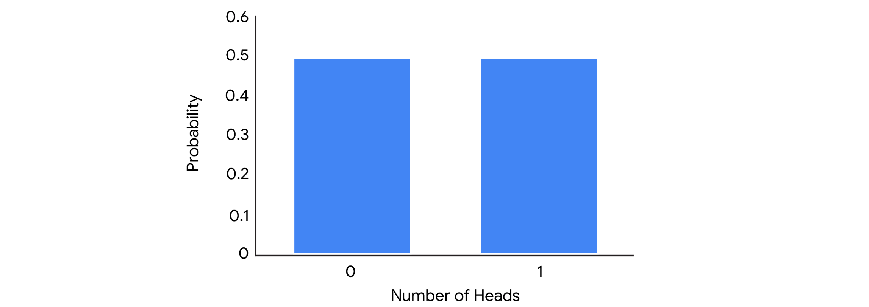

**Poisson distribution**

The **Poisson distribution** models the probability that a certain number of events will occur during a specific time period.

***Note:*** *The Poisson distribution can also be used to represent the number of events that occur in a specific space, such as a distance, area, or volume. In this course, we focus on time.*

The Poisson distribution represents a type of random experiment called a Poisson experiment. A Poisson experiment has the following attributes:

* The number of events in the experiment can be counted.
* The mean number of events that occur during a specific time period is known.
* Each event is independent.

For example, imagine you have an online website where you post content. Your website averages two views per hour. You want to determine the probability that your website will receive a certain number of views in a given hour.

This is a Poisson experiment because:

* The number of events in the experiment can be counted. You can count the number of views.
* The mean number of events that occur during a specific time period is known. There is an average of two views per hour.
* Each outcome is independent. The probability of one person viewing your website does not affect the probability of another person viewing your website.

On the histogram, the x-axis shows the number of views per hour, and the y-axis shows the probability of occurrence.

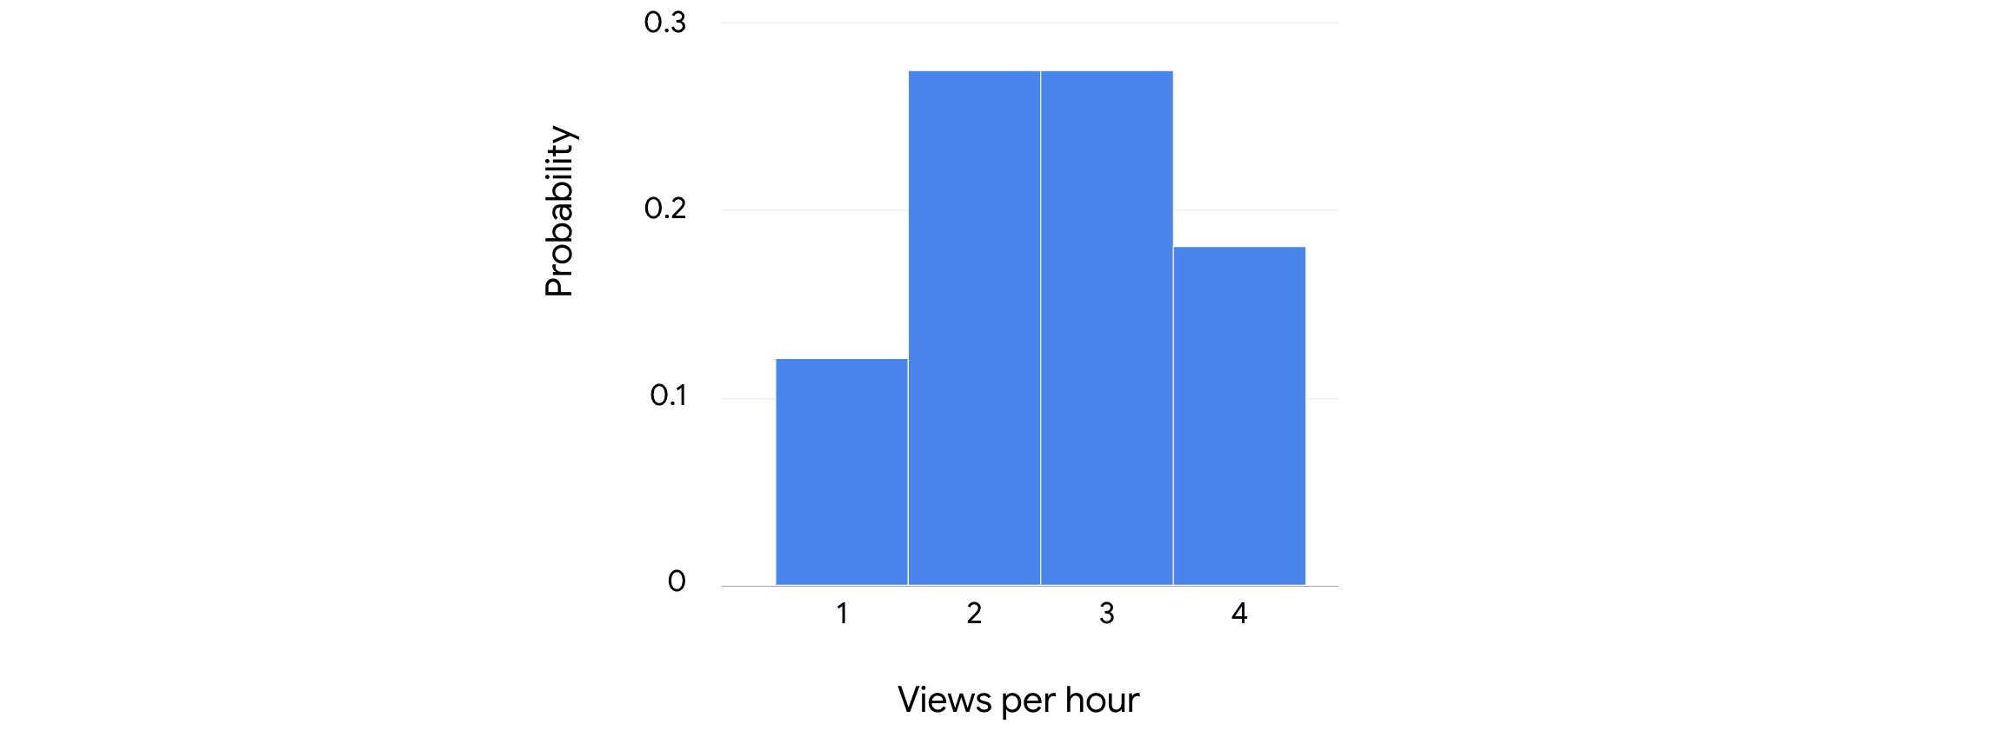

Data professionals use the Poisson distribution to model data such as the number of:

* Calls per hour for a customer service call center
* Customers per day at a shop
* Thunderstorms per month in a city
* Financial transactions per second at a bank

**Key takeaways**

Identifying the distribution of your data is a key step in any analysis, and helps you make informed predictions about future outcomes. In your future career as a data professional, you’ll use discrete distributions like the binomial and the Poisson to better understand your data. Knowing the probability distribution of your data will also help you choose the statistical method or machine learning model that works best for your analysis.

**Resources for more information**

To learn more about discrete probability distributions, refer to the following resources:

* This [article from Statistics How To](https://www.statisticshowto.com/discrete-probability-distribution/) provides an overview of the concept of discrete probability distribution and offers links to explore more about specific kinds of distributions such as the binomial and Poisson.